**VISVESVARAYA TECHNOLOGICAL UNIVERSITY**

**“JnanaSangama”,** Belgaum-590018, Karnataka



**BANGALORE INSTITUTE OF TECHNOLOGY**

K.R. Road, V.V.Puram, Bangalore-560 004



**Department of Computer Science & Engineering**

**Handouts for dissertation on**

**VIRTUAL HOSPITAL**

**Submitted By**

**USN Name**

**1BI10CS020 Boruthalupula Maneesh**

**1BI10CS036 Jyothi Prasad N M**

**1BI10CS104 Srivathsa S Rao**

**1BI10CS123 Vinay Hegde**

**for the academic year 2013-2014**

Under the Guidance of

**Prof. N THANUJA**

Asst. Professor

Department of Computer Science & Engineering

**Bangalore Institute of Technology**

Bangalore-560004

**PROBLEM STATEMENT**

This project aims at reaching healthcare services to distant locations to anyone who has access to an internet connection and also doctors and health facilities to expand their reach, beyond their offices.

**RELATED WORK AND DISADVANTAGES**

|  |  |
| --- | --- |
| **RELATED WORK** | **DRAWBACKS** |
| Kingston Hospital  (Kent, South East England) | Only results are communicated virtually |
| Virtual Healthcare Limited  (World Health Organization) | Patient has to approach some real world hospital |
| International Virtual eHospital (IVeH)  (Austin, Texas) | Targets underprivileged rural areas to set up the required hardware and personnel and not available for the general public |
| Virtual Naval Hospital  (US Navy) | It is just a digital library |
| yourvirtualhospital.com  (Kerala) | Complicated User Interface  (no more under use) |

**PROPOSED WORK**

|  |  |
| --- | --- |
| **PROPOSED WORK** | **ADVANTAGES** |
| Patient communicates his symptoms | Preliminary Diagnosis |
| Doctors and Patients can interact | Online Consultancy |
| Gather lot of helpful information | Health Tips |
| Consultation happens from home | Easy to use and saves time for patients |
| The patient will be provided with prescription alerts through SMS | Text alerts for medication prescriptions |

**DESIGN**

Fig1: Virtual Hospital block diagram

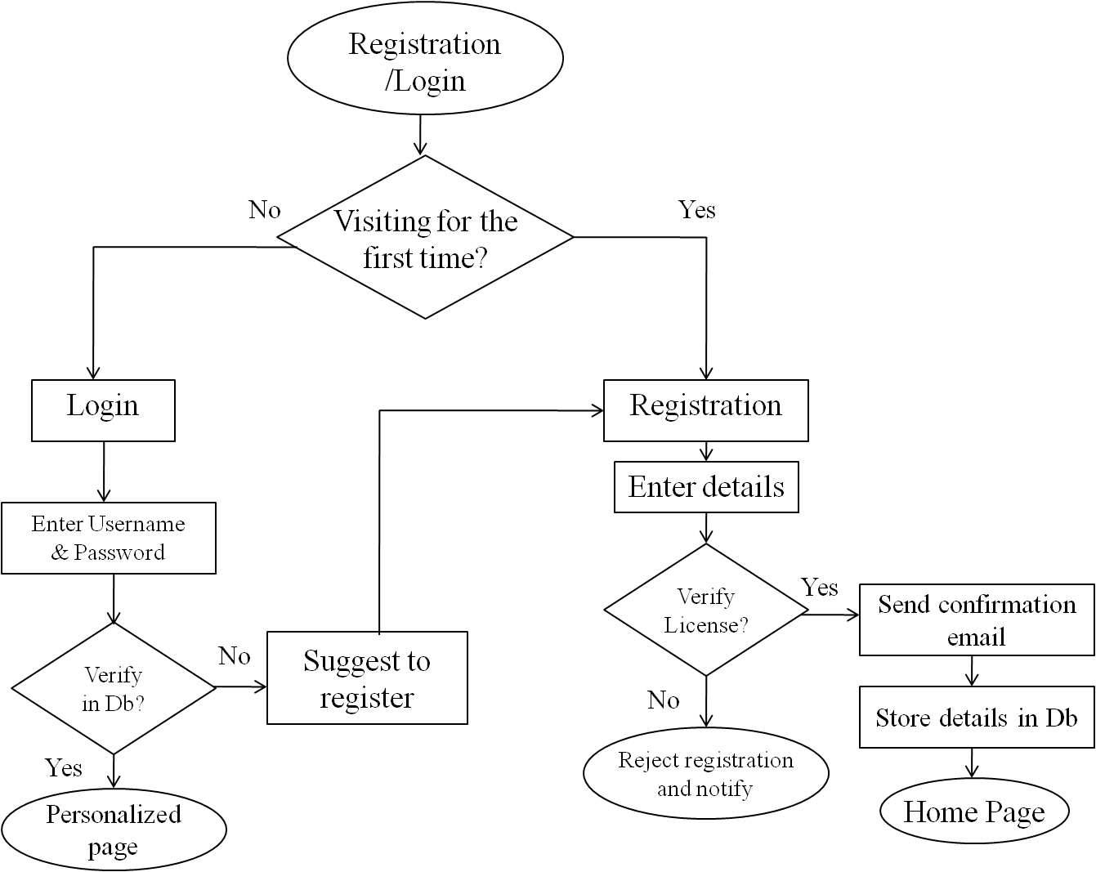

Fig 2: Flowchart for Doctor-Registration/Login

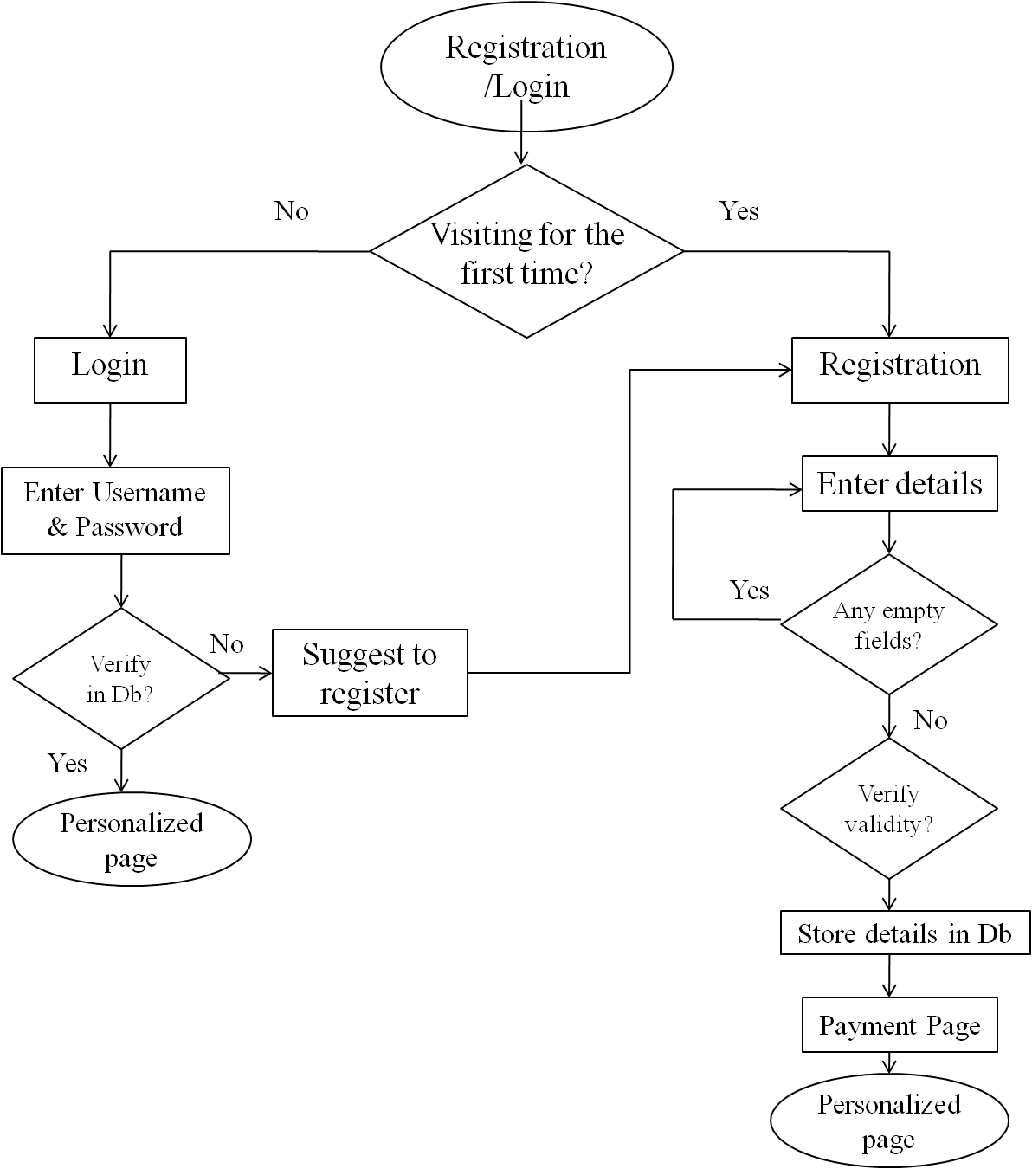

Fig 3: Flowchart for Patient-Registration/Login

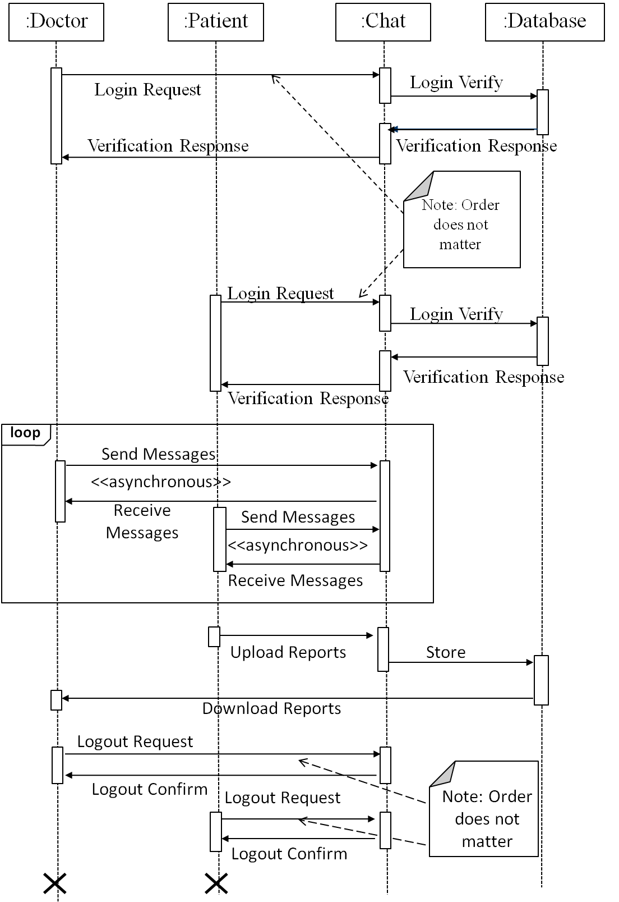

Fig 4: Sequence Diagram of Chat Application

**CONCLUSION**

Virtual Hospital brings the “hospital environment” online and eliminates the distance barrier existing between the doctors and patients.

The doctor analyzes the patient’s symptoms and interacts with the patient through a chat application. This is called the preliminary diagnosis. Prescriptions are generated in the standard format which is mailed to the patient and the patient also has an option to download the prescription through his profile which facilitates easier access to the prescriptions.

Patients are reminded about their medications at regular intervals through text alerts to their cellular phone. There has been multitude of attempts, some of them successful, in producing online medical solutions and some having their own drawbacks; we have tried to overcome the drawbacks of the existing solutions by creating a medical web application which is more comprehensive and easy to use.

**FUTURE WORK**

This web application, on link up with a bank, can be extended to include the fee payment option online. Also, if the registered doctors agree to share their license number officially through the medical council of India, then the license numbers can be used in our web application. If the medical electronic industry comes up with more tele-medical devices to conduct different medical tests from home, these devices can be used in our web application to send the results of the test conducted to the doctor for more thorough analysis.

**REFERENCES**

[1] <http://docs.oracle.com/javase/7/docs/api/>  
[2] <http://www.w3.org/TR/REC-xml/>   
[3] <http://xml.coverpages.org/xmlApplications.html>

[4] <http://www.codeproject.com/Articles/524120/A-Java-Chat-Application>

[5] <http://www.mkyong.com/java>

[6] <http://www.stat.berkeley.edu/~statcur/Workshop2/Presentations/XML.pdf>

[7] <http://docs.oracle.com/javaee/6/tutorial/doc/bncdq.html>

[8] Stephanie Bodoff et al: The J2EE Tutorial, 2nd Edition, Pearson Education, 2004.